**ARYAMAN MISHRA**

**19BCE1027**

1. Create an interactive dashboard for the Global Store [dataset](https://lms.vit.ac.in/mod/resource/view.php?id=34426) and your own (any dataset may be downloaded) with at least 4 sheets by applying Actions such as Filter, Hover and URL. Explain the step by step process and insights.

**Create connection between Orders and People.**

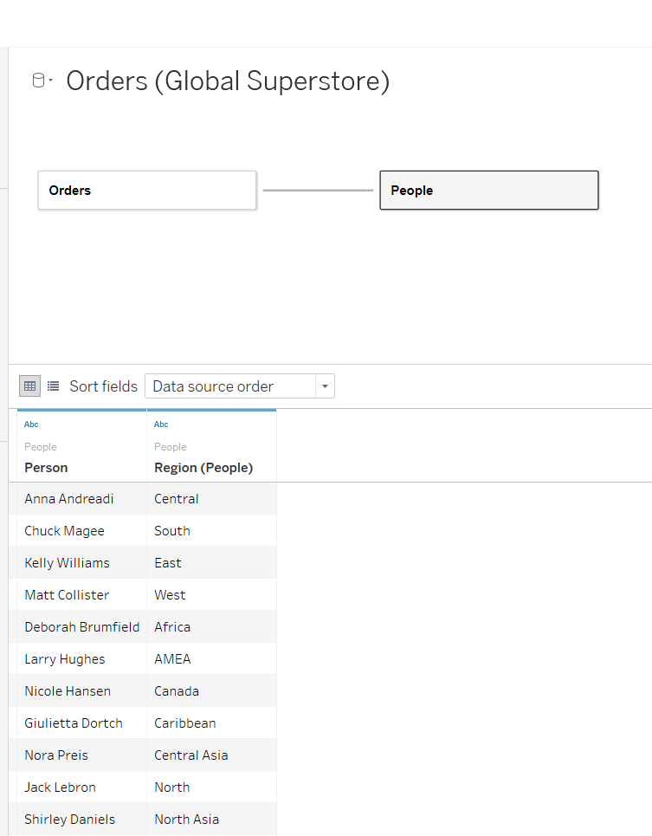

**Create Profit by Category and Sub Category.**

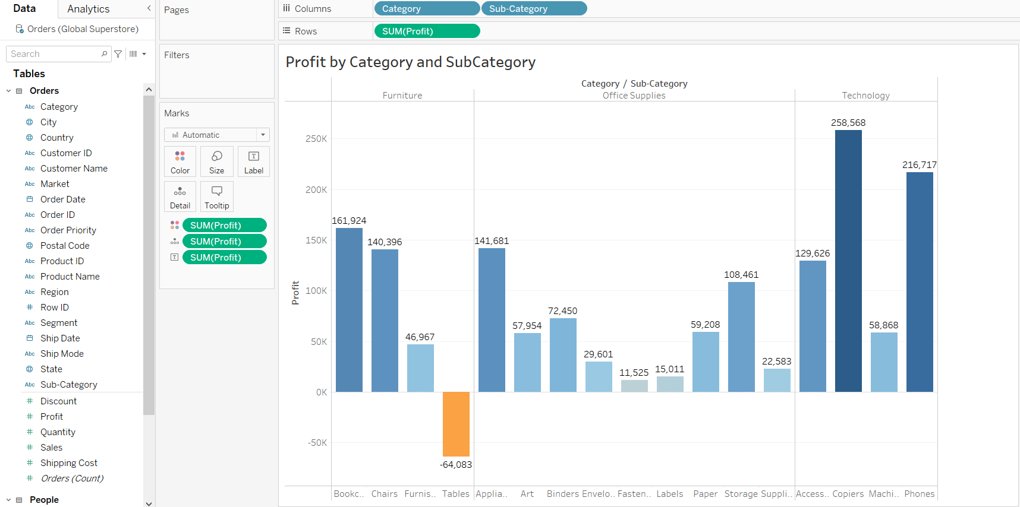

**Create Sales by Category and Subcategory.**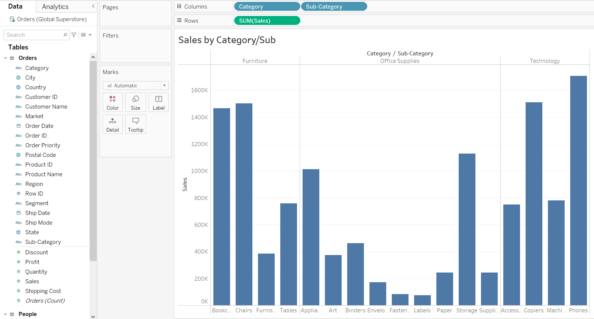

**Add labels to order by category and sub-category.**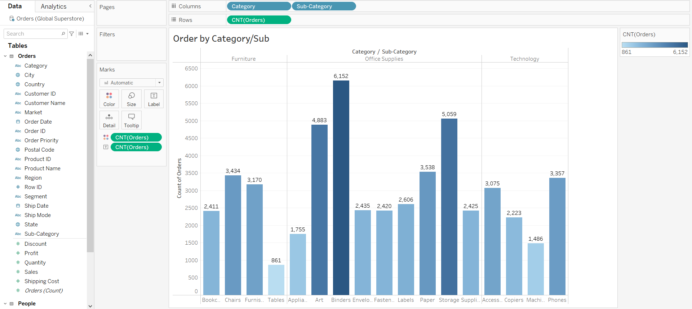

**Create filtered page for categories.**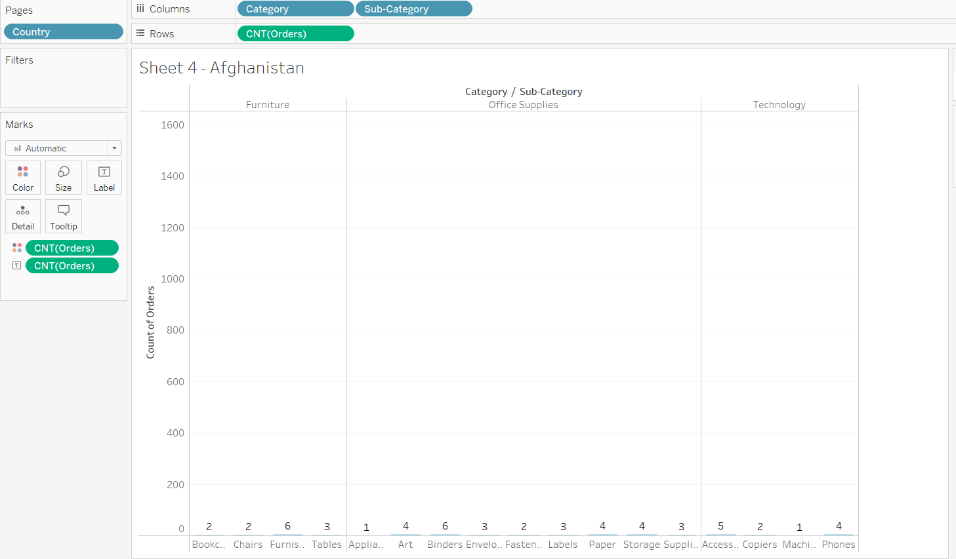

**Create filter for countries.**

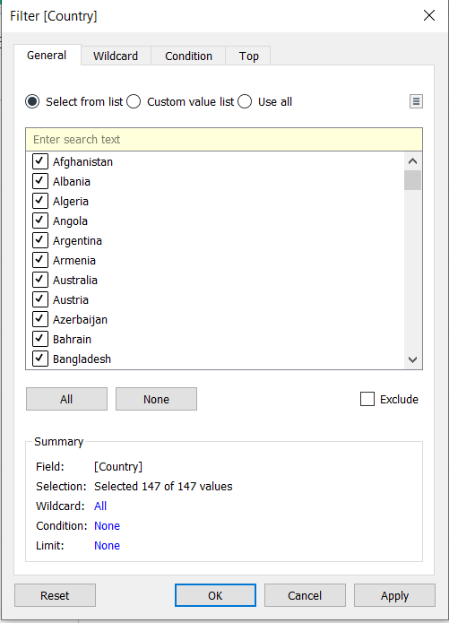

**View Data for Australia.**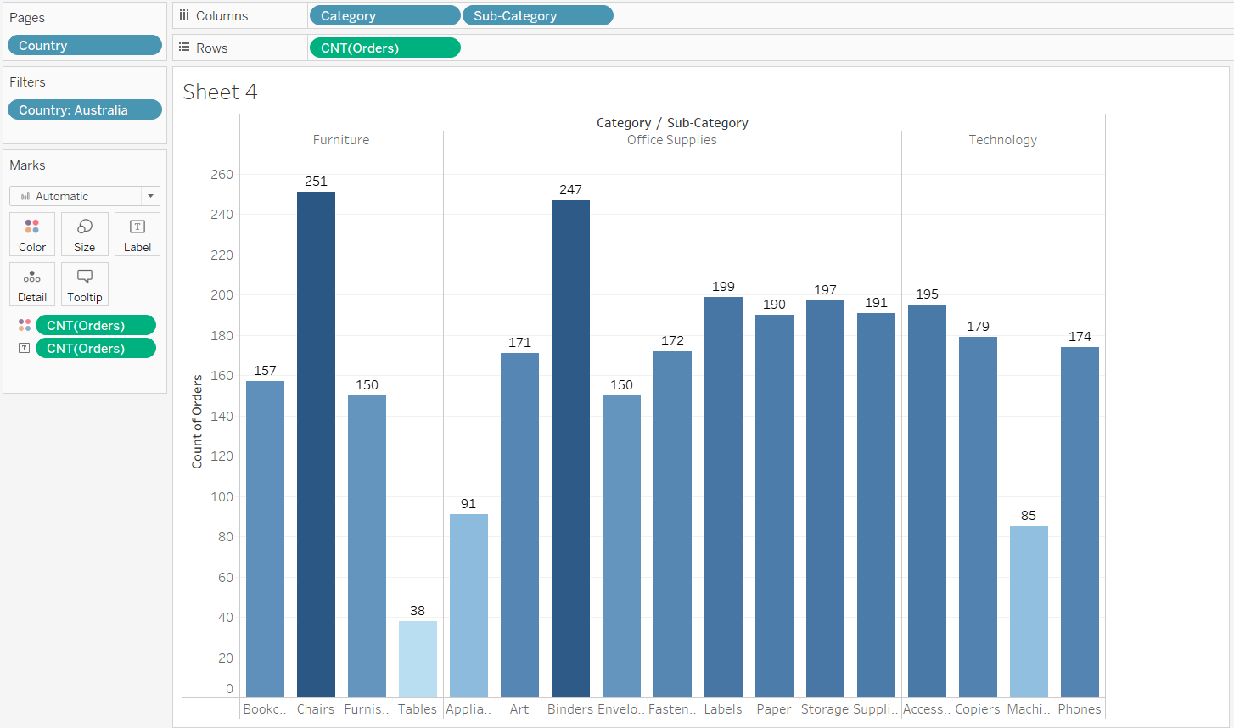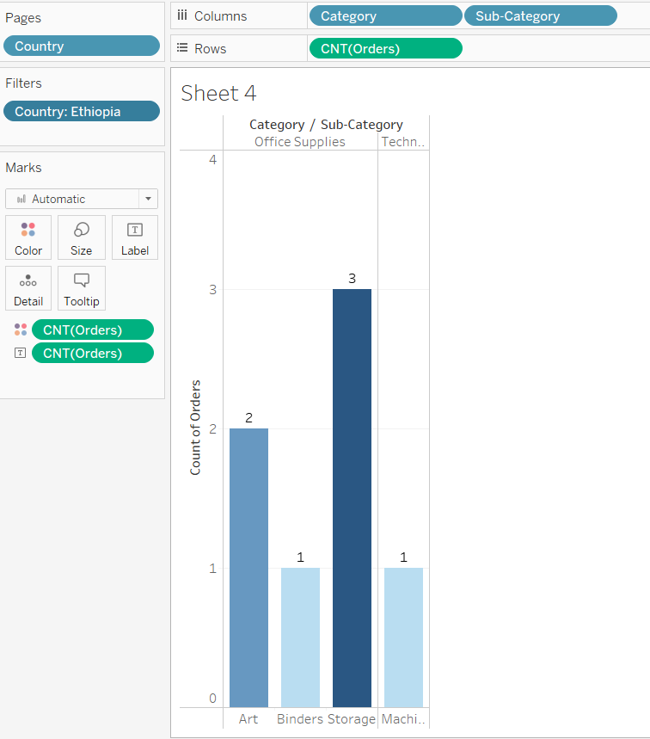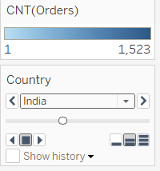

**View Data for India.**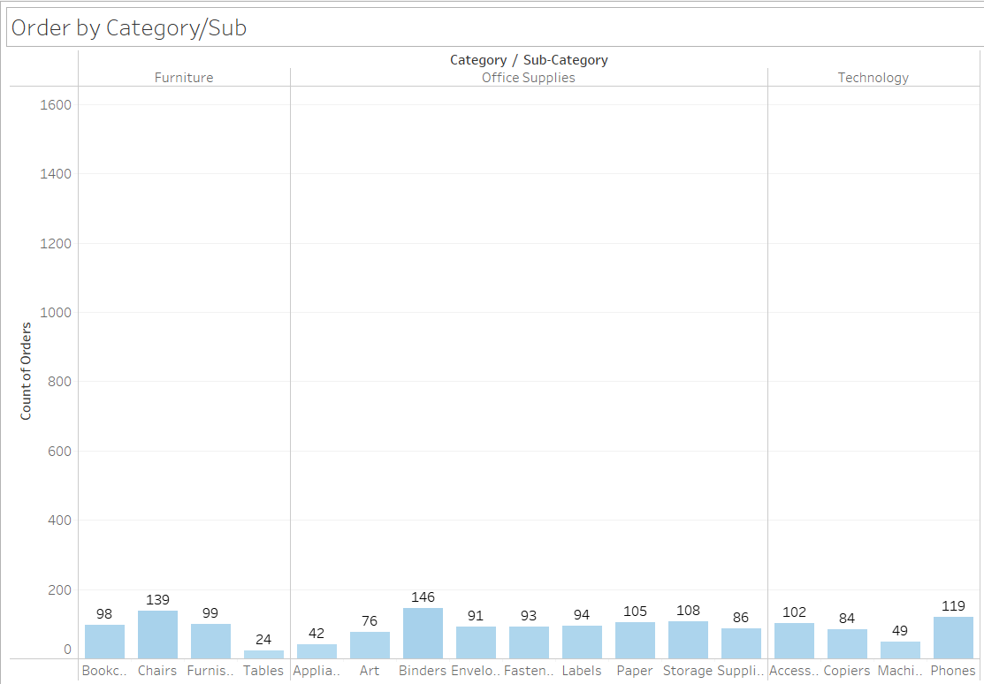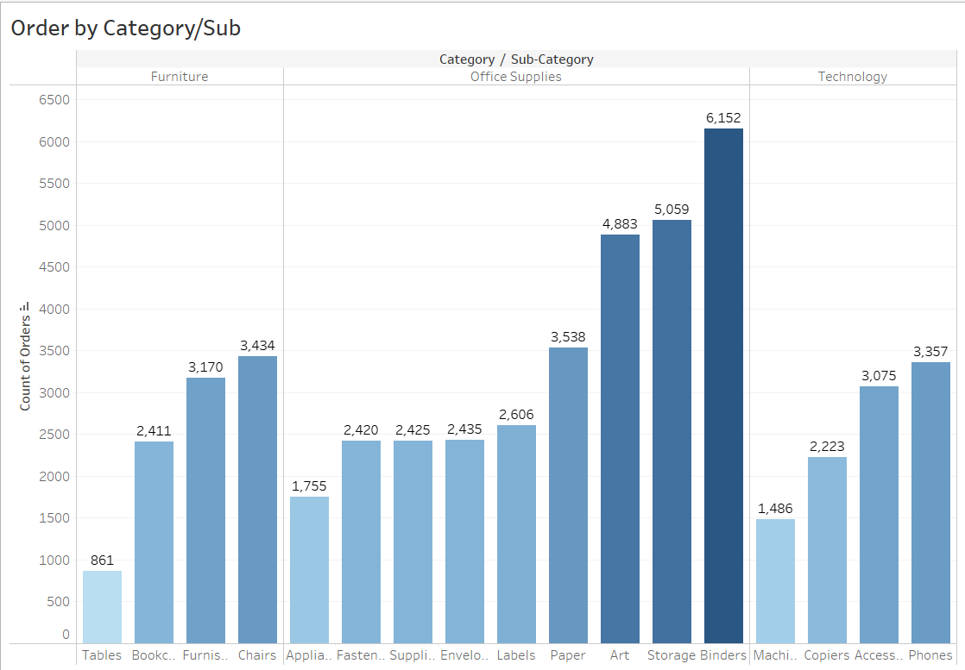

**Sort data in ascending and descending order.**

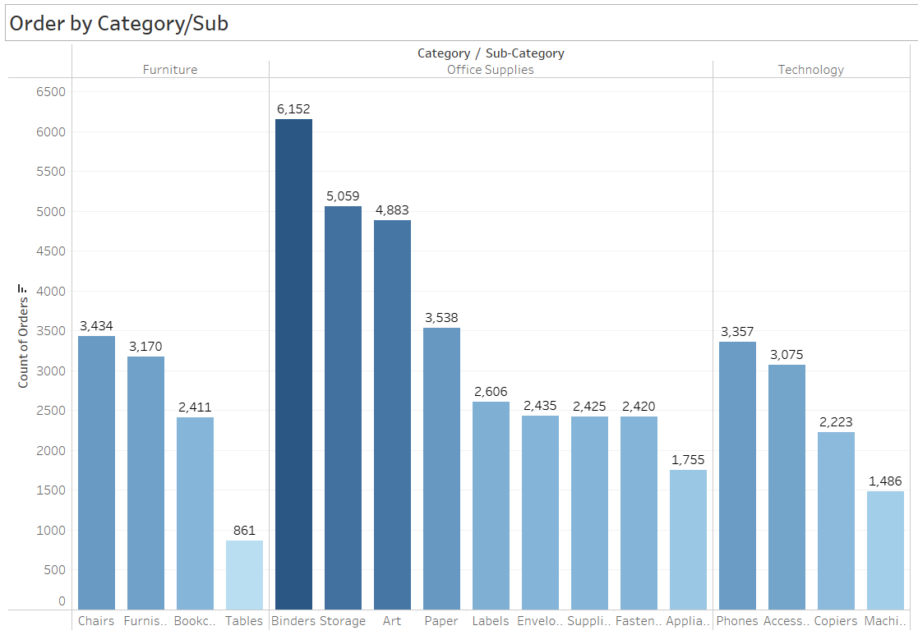

**Create variations in data charts using Show Me Menu.**

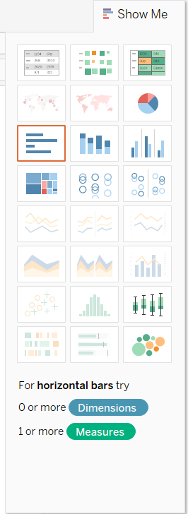

**Check layout for different devices.**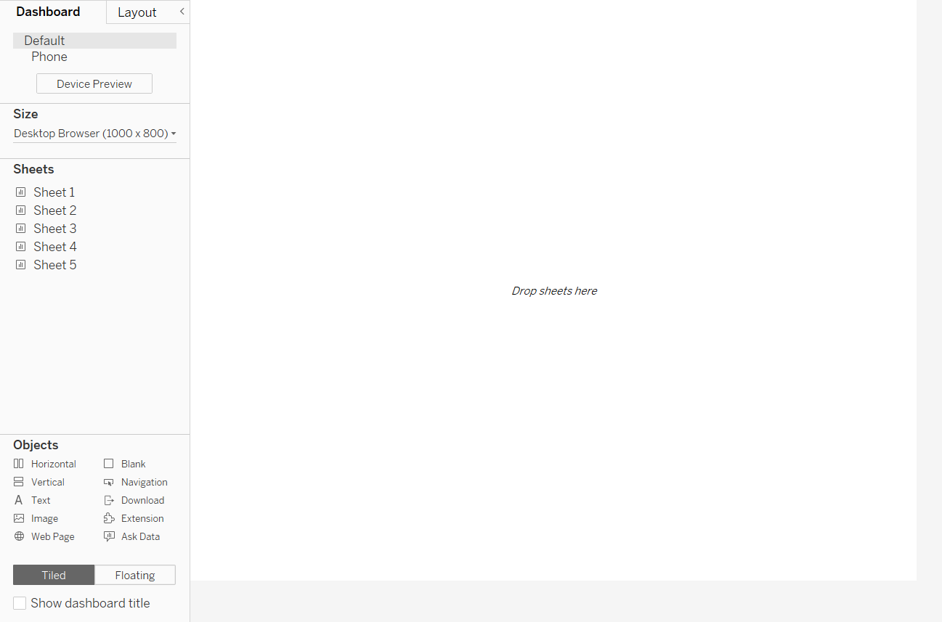

**Join all 4 sheets to create 1 interactive dashboard.**

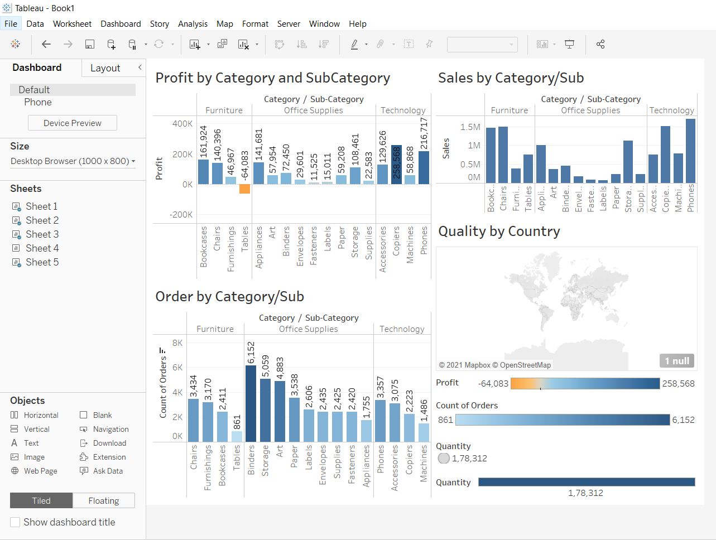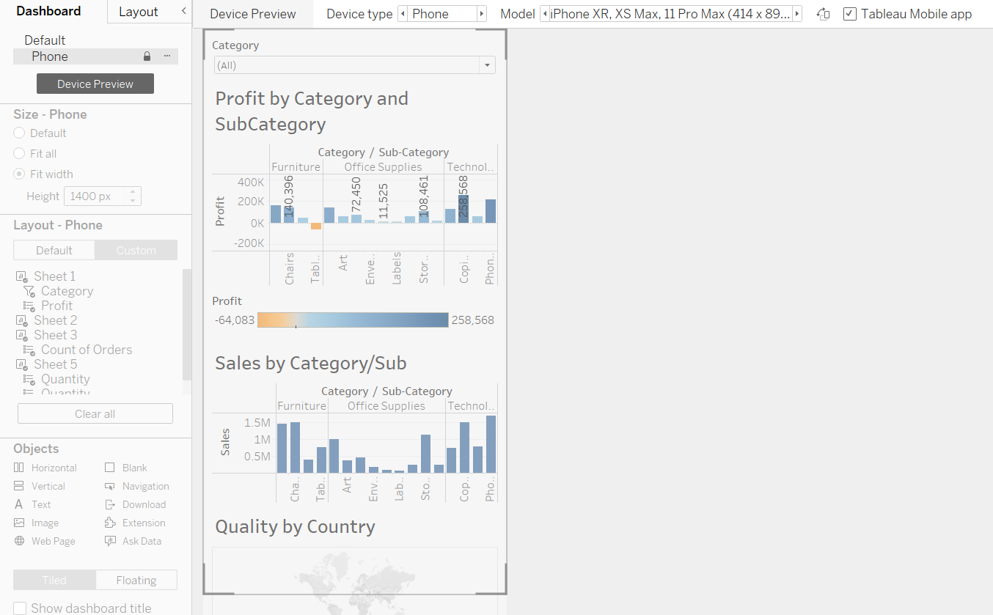

**Filter Action.** 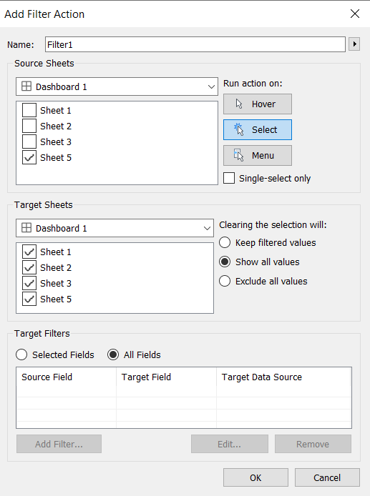

**Check Quality by Country.**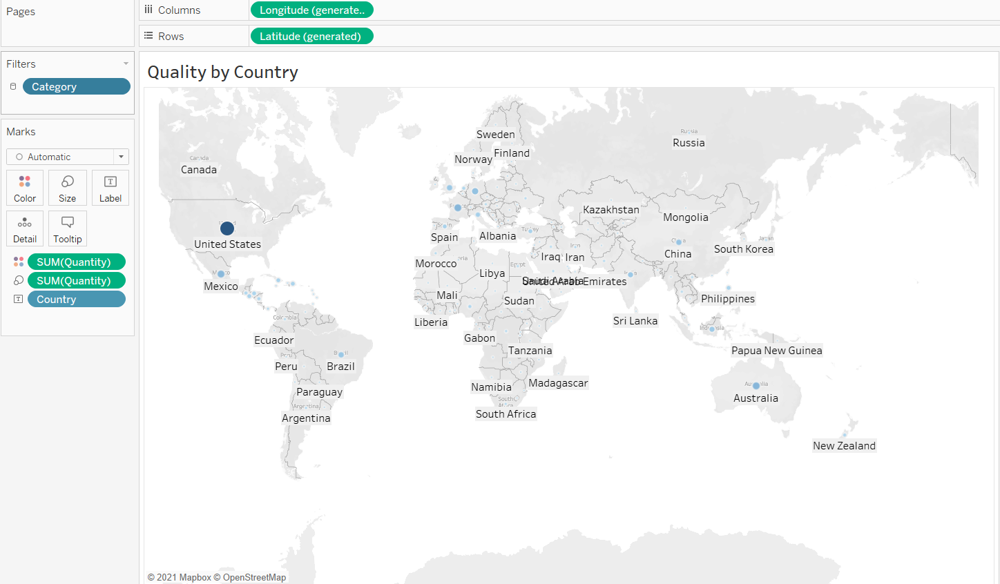

**Create actions for dashboard.**

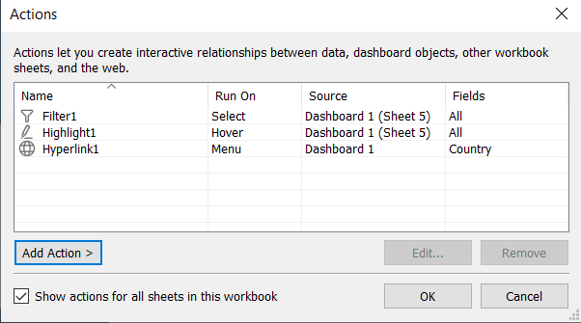

**Create Highlight for Countries.**

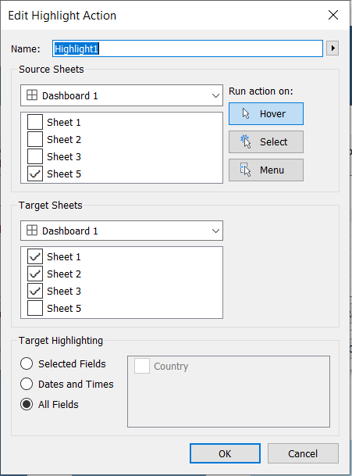

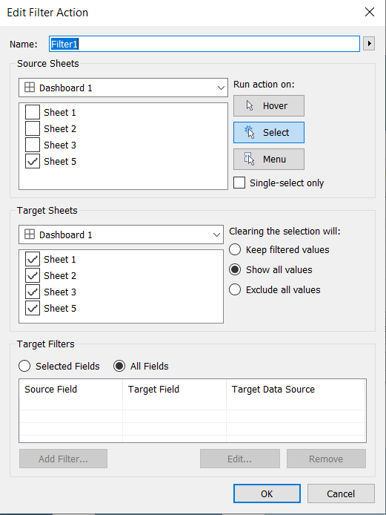

**Create Hyperlink action to get Wikipedia page on a country.**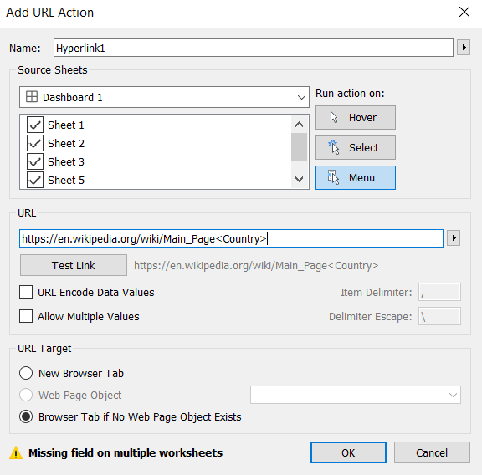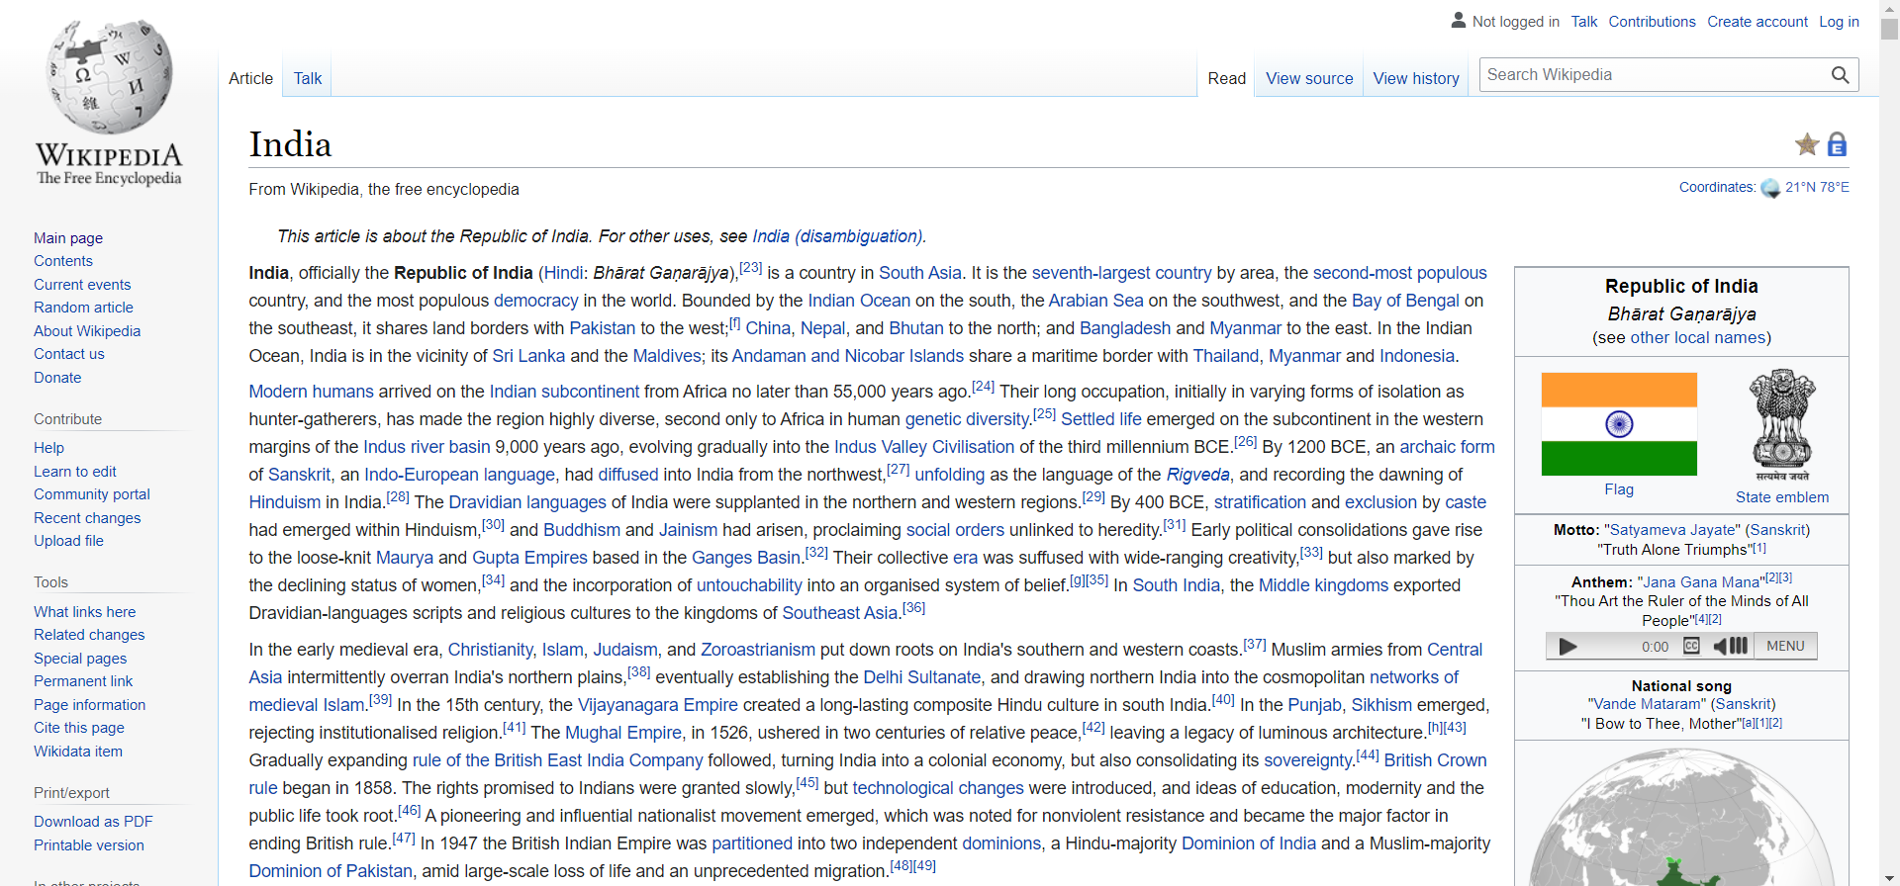

**Create an interactive dashboard of your own dataset (any dataset may be downloaded) with at least 4 sheets by applying Actions such as Filter, Hover and URL. Explain the step by step process and insights.**

View Dataset.

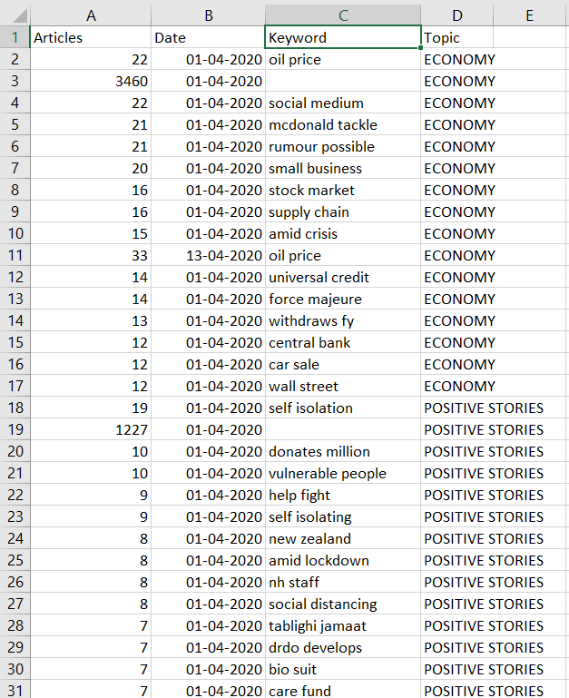

In sheet1,view all keywords and rank by percentage.

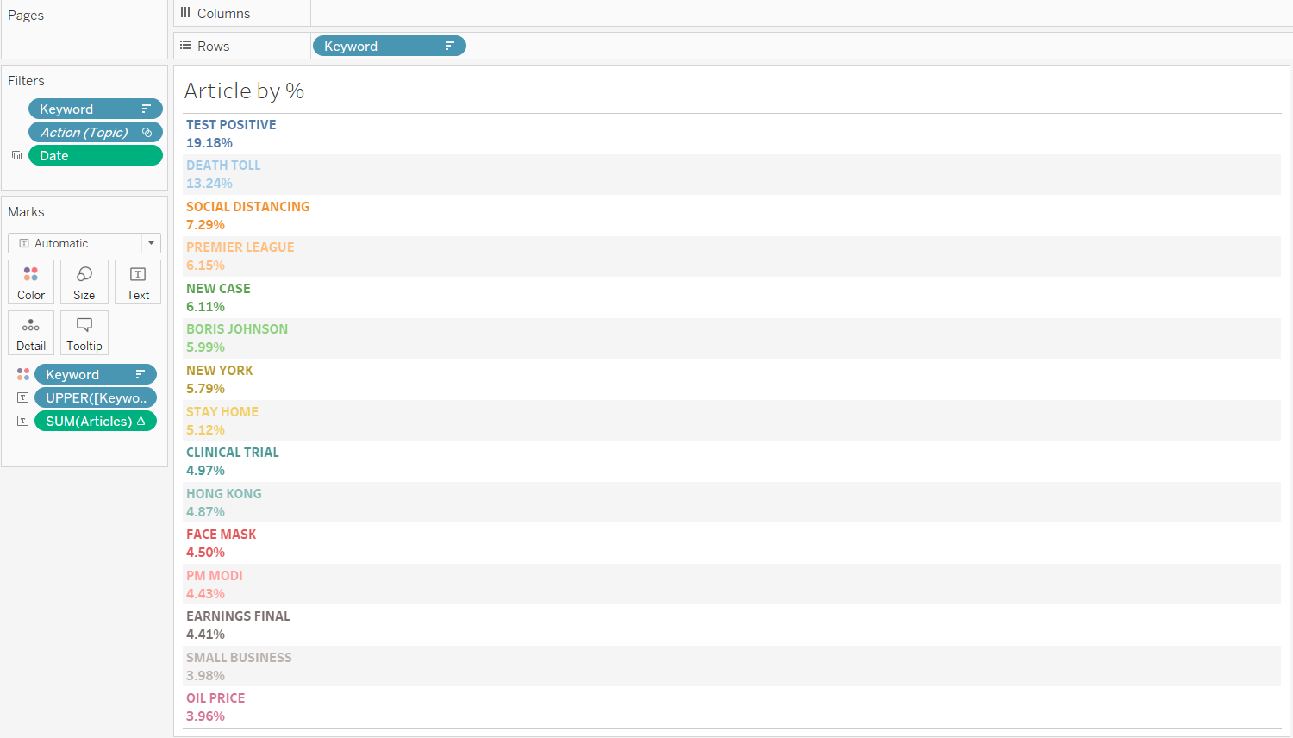

In sheet 2 create bar chart for sheet1.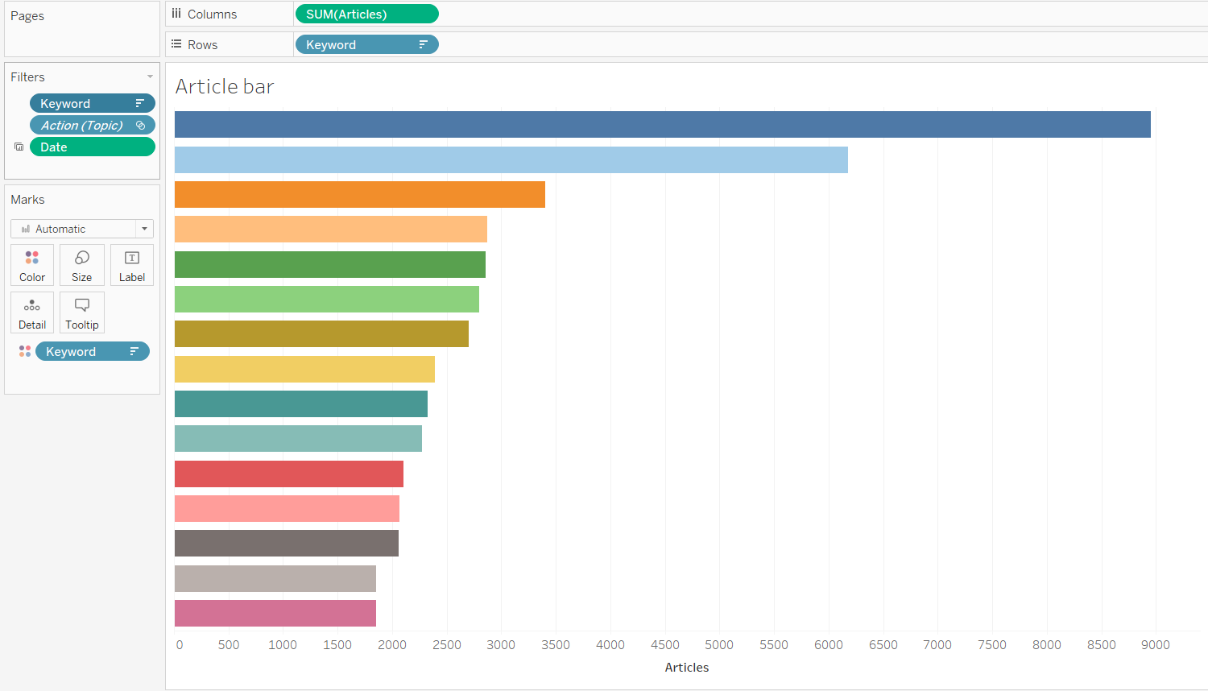

Create graphs with date and rank of keywords.

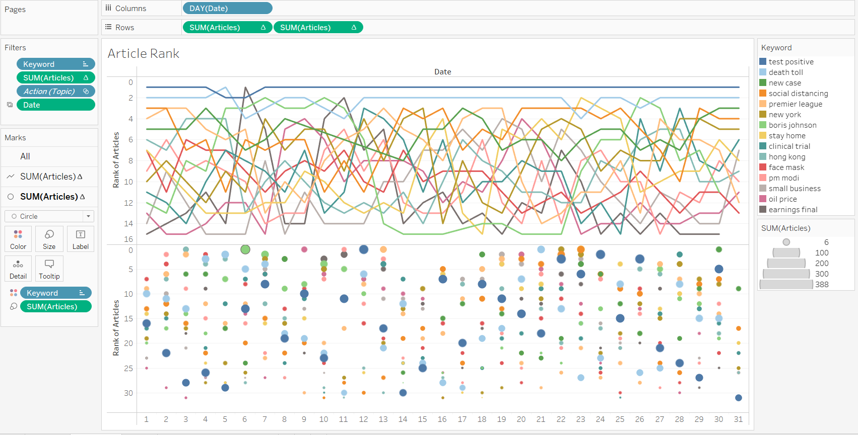

Create Dashboard Filter Menu.

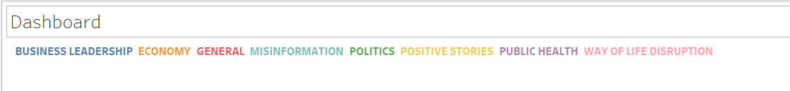

Create Actions.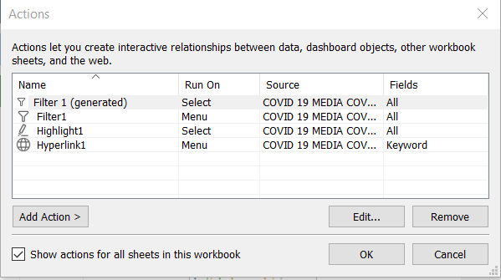

Create Filter.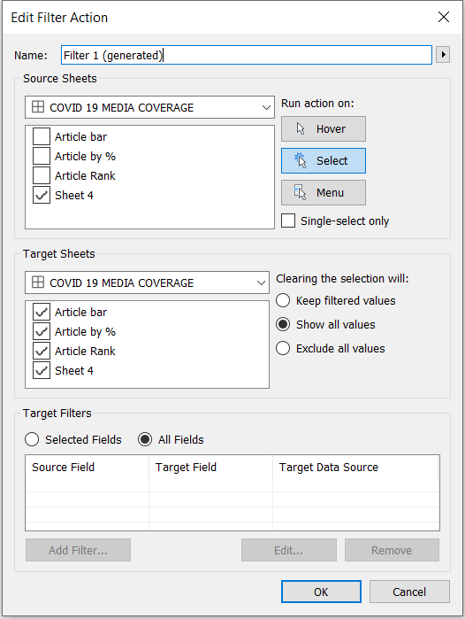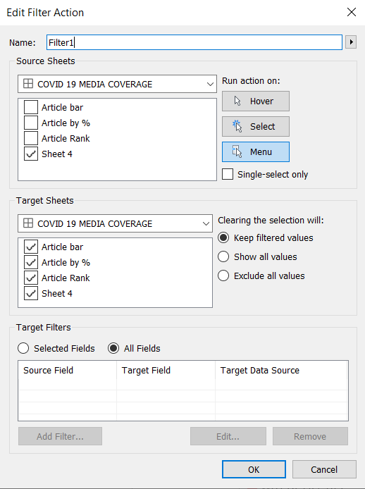

Create Highlight Action.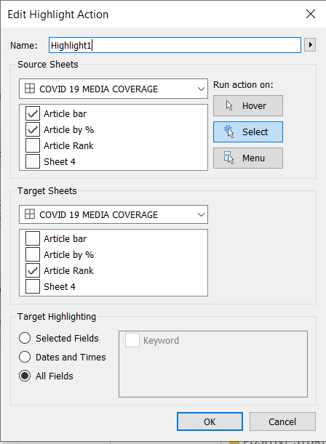

Create Hyperlink to browse keywords on google.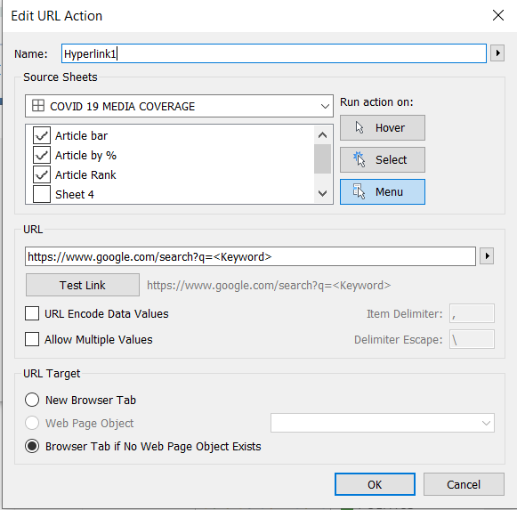

Final Result: